**G.Bhuvaneshwari**

621519106014

ASSIGNMENT 2

Step 1: Upload the Pharma-Sales-Dataset to Cognos Analytics

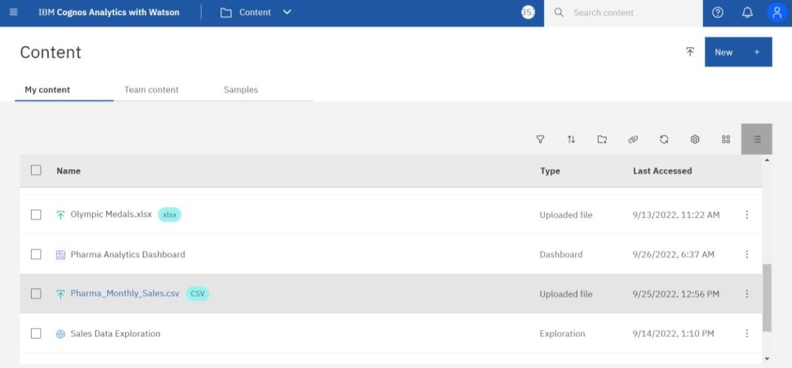

Step 2: Explore a Pharma-Sales-Dataset

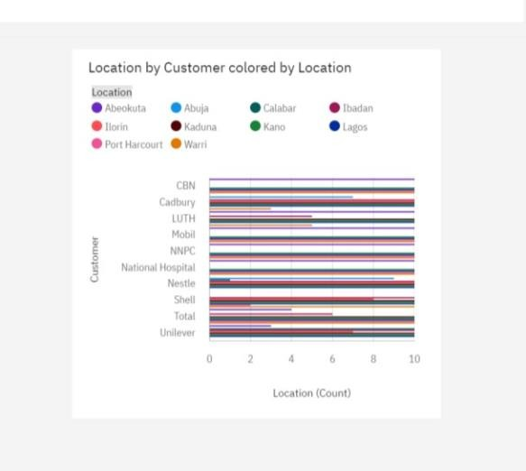

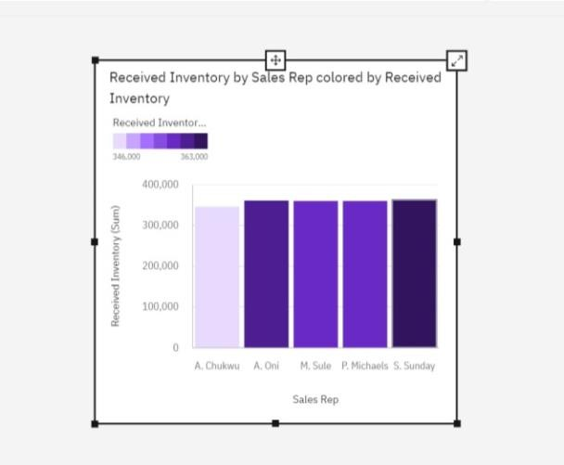

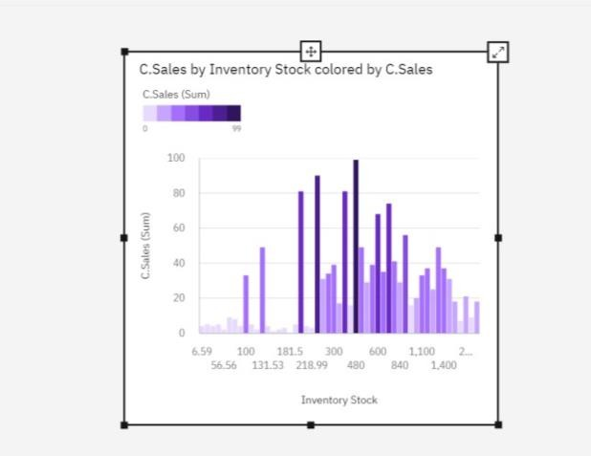

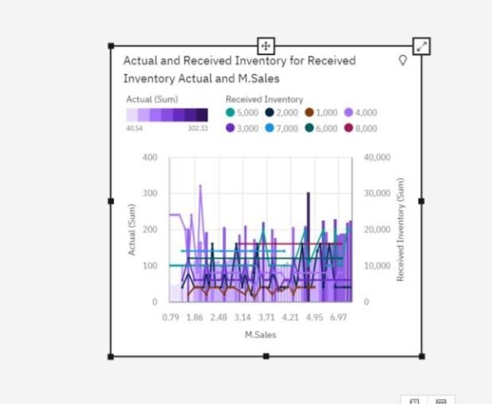

Step 3: Create Interactive Dashboard Here, below the dashboard link

[https://us3.ca.analytics.ibm.com/bi/?perspective=dashboard&pathRef=.my_fold](https://us3.ca.analytics.ibm.com/bi/?perspective=dashboard&pathRef=.my_folders%2FPharma%2BAnalytics%2BDashboard&action=view&mode=dashboard&subView=model0000018378fc55fc_00000002) [ers%2FPharma%2BAnalytics%2BDashboard&action=view&mode=dashboard](https://us3.ca.analytics.ibm.com/bi/?perspective=dashboard&pathRef=.my_folders%2FPharma%2BAnalytics%2BDashboard&action=view&mode=dashboard&subView=model0000018378fc55fc_00000002) [&subView=model0000018378fc55fc_00000002](https://us3.ca.analytics.ibm.com/bi/?perspective=dashboard&pathRef=.my_folders%2FPharma%2BAnalytics%2BDashboard&action=view&mode=dashboard&subView=model0000018378fc55fc_00000002)

Step 4: STORY

Here, the story link is below

[https://us3.ca.analytics.ibm.com/bi/?perspective=story&pathRef=.my_folders%](https://us3.ca.analytics.ibm.com/bi/?perspective=story&pathRef=.my_folders%2FMy%2BAnalytics%2BStory%2FPharma%2BAnalytics%2BStory&action=view&sceneId=model00000183794e51c2_00000001&sceneTime=7300) [2FMy%2BAnalytics%2BStory%2FPharma%2BAnalytics%2BStory&action=vi](https://us3.ca.analytics.ibm.com/bi/?perspective=story&pathRef=.my_folders%2FMy%2BAnalytics%2BStory%2FPharma%2BAnalytics%2BStory&action=view&sceneId=model00000183794e51c2_00000001&sceneTime=7300) [ew&sceneId=model00000183794e51c2_00000001&sceneTime=7300](https://us3.ca.analytics.ibm.com/bi/?perspective=story&pathRef=.my_folders%2FMy%2BAnalytics%2BStory%2FPharma%2BAnalytics%2BStory&action=view&sceneId=model00000183794e51c2_00000001&sceneTime=7300)

=====================THANK YOU====================